Chapter 17, Solution 67.

The Schematic is shown below. In the Transient dialog box, we type “Print step = 0.01s, Final time = 36s, Center frequency = 0.1667, Output vars = v(1),” and click Enable Fourier. After simulation, the output file includes the following Fourier components,

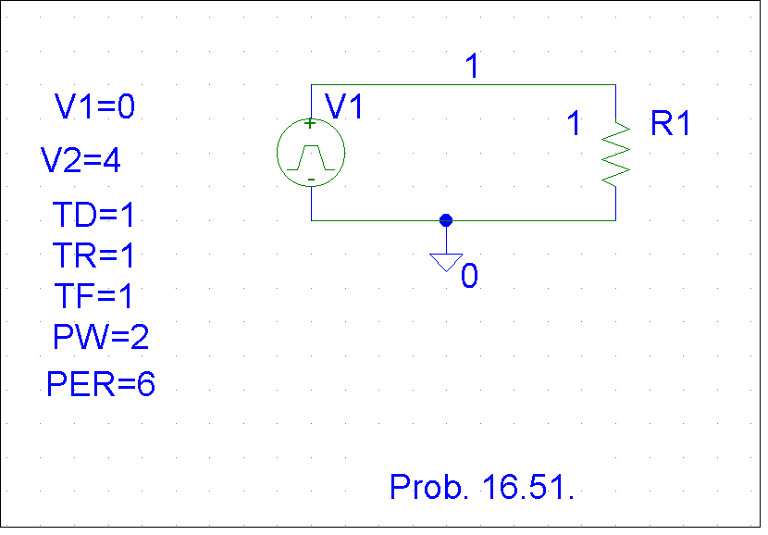
FOURIER COMPONENTS OF TRANSIENT RESPONSE V(1)

DC COMPONENT = 2.000396E+00

HARMONIC FREQUENCY FOURIER NORMALIZED PHASE NORMALIZED
NO (HZ) COMPONENT COMPONENT (DEG) PHASE (DEG)

1 1.667E-01 2.432E+00 1.000E+00 -8.996E+01 0.000E+00
2 3.334E-01 6.576E-04 2.705E-04 -8.932E+01 6.467E-01
3 5.001E-01 5.403E-01 2.222E-01 9.011E+01 1.801E+02
4 6.668E-01 3.343E-04 1.375E-04 9.134E+01 1.813E+02
5 8.335E-01 9.716E-02 3.996E-02 -8.982E+01 1.433E-01
6 1.000E+00 7.481E-06 3.076E-06 -9.000E+01 -3.581E-02
7 1.167E+00 4.968E-02 2.043E-02 -8.975E+01 2.173E-01
8 1.334E+00 1.613E-04 6.634E-05 -8.722E+01 2.748E+00
9 1.500E+00 6.002E-02 2.468E-02 9.032E+01 1.803E+02

TOTAL HARMONIC DISTORTION = 2.280065E+01 PERCENT

